Comberton Eco Award  Section | Evidence
Head:  This section should include a project on any environmental / sustainability topic. This could be presented as a PowerPoint, written report, video or in any format. | The presentation should be attached with this document. A short description should be written here.
Heart:  This section should involve engaging with Nature. This could involve growing something from seed, bird watching, visiting an area of environmental interest, hunting for mushrooms, identifying plants in your garden……  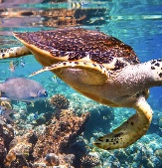 | Evidence could include photos or a written account of what was done. Please write here in this box.
Hands:  This section should involve taking a personal action that reduces your carbon footprint or makes the world a more sustainable place.  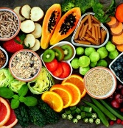 | Evidence could include photos or a written account of what was done. Please write here in this box.
